My Personal Word Wall | 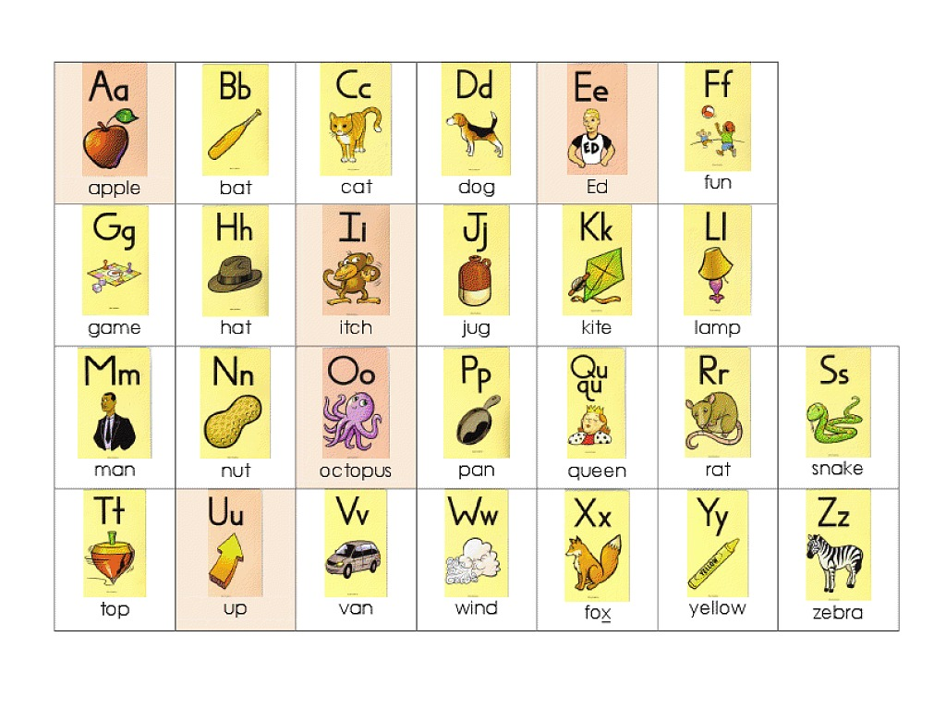  and a all as at am are an | ball be  boy by but | can  come | do  day does  did |  | for  friend  from | go get  got  good
he her him has had his  have | is in  I it if  into |  |  | like look let | me my man mom many | no  not | on of  or out
play  put | quit | ran  run  read | so  see sat sit  she said | the to two this they that | up  us under | very | when where who with we  what was  were will
 | you yes  your | zoo | Important Words For Me:  Unit 6 Words – are, who, what, were, when, there, where, here

